Pozyx – Tutorial 2: Ready To Localise

Setup Notes

Reference:

<https://www.pozyx.io/Documentation/Tutorials/ready_to_localize/Python>

Step 1:

Assumes all files, libraries, etc have been downloaded and installed, refer to:

C:\Projects\Pozyx\Documentation\Pozyx - Tutorial 1 - Ready To Range - Setup Notes.doc

Note: user must also manually install “python-osc” module

Go to command prompt and enter:

C:\> pip install python-osc

Step 2:

Run Tutorial 2: Ready-To-Localise (Python version)

[(See](https://www.pozyx.io/Documentation/Tutorials/ready_to_range/Python) reference above)

Run Python script:

C:\Projects\Pozyx\PythonFiles\Pozyx-Python-library-master\tutorials\ready_to_localize.py

Notes: Ensure anchor ids and relative (x, y, z) co-ordinates (mm) are valid to the setup. If not, re-enter appropriate values prior to running the script.

Eg:

anchors = [DeviceCoordinates(0x675a, 1, Coordinates(0, 0, 1100)),

DeviceCoordinates(0x674d, 1, Coordinates(6000, 0, 700)),

DeviceCoordinates(0x675b, 1, Coordinates(6000, 5500, 1400)),

DeviceCoordinates(0x6717, 1, Coordinates(-30, 6000, 1600))]

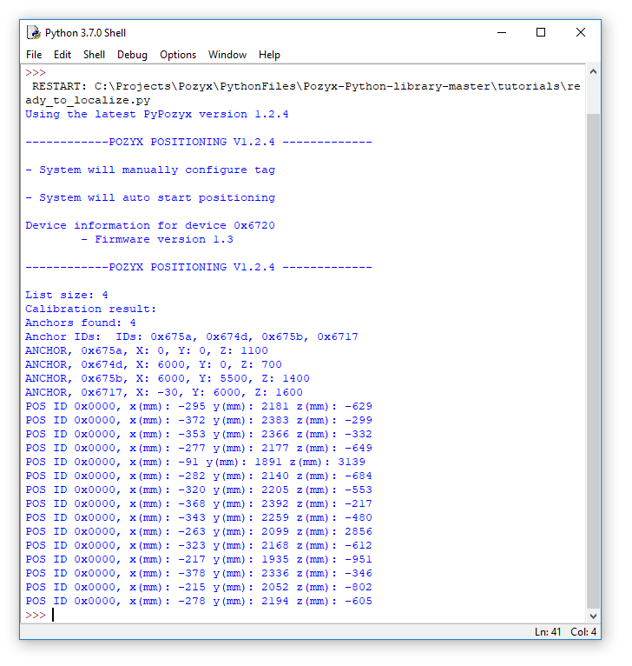

Figure 1: Sample Output